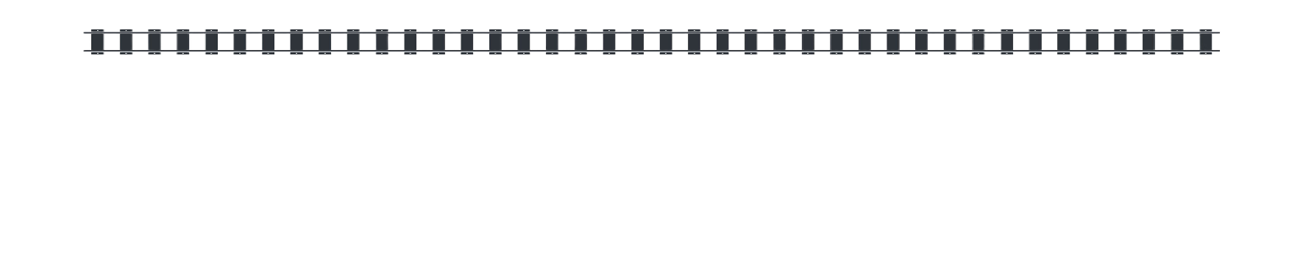
www.ChooChooBarn.com : 717-687-7911 www.StrasburgTrainShop.com : 717-687-0464

CREATE THE NEXT GREAT ANIMATION FOR THE CHOO CHOO BARN!
Junior High School Student Design Challenge
Are you a creative problem solver with a passion for design, engineering, and animation? Here's your chance to leave your mark on one of the most iconic model train layouts in the country!
The Choo Choo Barn is holding a competition open to all Junior High School students to design a brand-new animation for our world-famous model train display in Strasburg, PA!

WHAT YOU'LL DO:
- Design and draw your own animated scene or feature.
- Show how it will move using motors and linkages.
- Include scale dimensions for an O-scale (1:48) display.
- Submit your drawings, descriptions, and any additional ideas on how it would work.
WHAT YOU COULD WIN:
- 1st Place: $300 prize and your animation brought to life by our talented staff and added to our layout with your name on it! You will also receive 4 Complimentary Tickets to the Choo Choo Barn.
- 2nd Place: $200 prize. You will also receive 4 Complimentary Tickets to the Choo Choo Barn.
- 3rd Place: $100 prize. You will also receive 4 Complimentary Tickets to the Choo Choo Barn.

COMPETITION GUIDELINES:
- Eligibility:
  - Open to all students in grades 6 through 8. One participant is allowed per submission. This is not a group project.
  - Must be submitted through a school or teacher representative.
- Design Requirements:
  - Design must be a new and original idea that fits within the theme and spirit of the Choo Choo Barn.
  - Final design must be drawn to O-scale (1:48) and include dimensions of scaled project.
  - Must show how the animation will work, including labeled diagrams of motors, gears, linkages, or other mechanics required.
  - Include a written explanation (1-2 paragraphs) describing the animation and how it works.
- Submission Materials:
  - Completed design sketches (hand-drawn or digital)
  - Scale drawing with dimensions
  - Mechanical/movement diagram
  - Written description
- Deadline:
  - All entries must be submitted by 6/15/2025 to be eligible for judging.
- Judging Criteria:
  - Creativity and originality
  - Functionality and engineering feasibility
  - Accuracy of scale and clarity of drawings
  - Quality of explanation
- How to Submit:
  - Fill out the submission form (linked on the website) and then send with your design
  - Mail or deliver entries to: Choo Choo Barn Animation Contest
226 Gap Road, PO Box 130, Strasburg, PA 17579
  - Or email to: Rae@choochoobarn.com with subject line "Student Animation Contest"

Bring your imagination to life, and become part of Choo Choo Barn history!
Questions? Contact us at 717-687-7911 and ask for Rae. Or you can contact us by emailing Rae@choochoobarn.com.
Let's inspire the next generation of makers and engineers, one animation at a time!

